POINTS OF NOTE / RECENT CHANGES

Tax Rates (incl. Medicare Levy) – 2024/25

Individuals Tax Rate
Less than $18,200 Nil.
From $18,201 to $45,000 18%
$45,001 to $135,000 $5,188 + 32%
$135,001 to $190,000 $33,988 + 39%
Above $190,001 $55,438 + 47%

Company tax rate is 25% for companies with a turnover less than $50 million and have no more than 80% base rate entity passive income.

INCOME TAX

Recent Tax Announcements

- The small business temporary full expensing rules ended on 30 June 2023, replaced with a $20,000 instant asset write off (see below).
- Super Guarantee percentage increases to 12% from 1st July 2025
- STP Finalisation must be done by all employers by 14th July 2025. If you need assistance with this please contact our office.
- The shortcut method of claiming home office expenses is 70c per hour. As this rate includes phone, internet, electricity and computer supplies and requires a diary for the full year to substantiate the claim, it is likely that calculating the relevant portion of actual expenses will give the best result.
- For Business the extra 20% deduction for energy efficiency and training expenses will need to be calculated.

Instant Asset Write-off (IAWO)
The depreciation rules have undergone a significant change, reverting back to the IAWO rules, with a $20,000 limit. If you choose to apply the IAWO, which enables a full depreciation of assets under $20,000, then not only must you apply this method to all assets purchased during that year, but you must also enter the pooling system and write off your pool balance in full if it falls below $20,000.

Minimum Wage Increase
A recent announcement by the Fair Work Commission has seen a 3.5% increase in the National minimum wage from 1st July 2025. This will flow onto other awards. Please ensure you review your relevant award before the first payday after the 1st July 2025.

ATO Interest Deductibility Changes
The ATO is reminding taxpayers that from the 1st July 2025 interest charged by the ATO for late payments or underpayments will no longer be tax deductible. This applies to all general interest charges incurred on or after 1st July 2025, regardless of whether the debt relates to an earlier income year.

Logbook
The ATO have flagged greater scrutiny of motor vehicle logbooks. Ensure one is kept every five years, that it is kept for a 12-week period and that the description of each journey, both work related and private, provides appropriate details of the trip.

Electric Vehicles
There is no fringe benefits tax payable in respect of electric vehicles, up to $91,387, so this provides a significant incentive to purchase work vehicles for employees, or to purchase them under a salary sacrifice arrangement. This FBT exemption also applies to registration, insurance, electricity and repairs. Due to the difficulty of ascertaining the electricity cost the ATO allows a rate of 4.2c per km as a shortcut.

SUPERANNUATION

Superannuation Guarantee
From 1st July 2025 the compulsory superannuation rate has increased from 11.5% to 12%. All employers should now be using single touch payroll to report wages, with these systems automatically updating to the 12%.

Concessional Contribution Limits
The annual concessional limits for superannuation contributions are increasing for the 2025 financial year.

- Up to $30,000 for employer, salary sacrifice and personal deducted contributions combined.
- Up to $120,000 for personal undeducted contributions, or $360,000 over three years if under 75.

The carry forward concessional contributions rule, that allows unclaimed contributions from the previous five years for those with super balances of less than $500,000, can be very useful.

Note the Government Co-Contribution and the low-income Superannuation tax offset, both up to $500 for taxpayers with adjusted assessable income of less than $60,400 or $37,000 respectively, is well worth considering.

As previously advised the work test previously required for people aged 68-75 non-concessional super contributions has been abolished. This test remains for concessional contributions. The bring forward $360,000 rule not previously accessible by people 68-75 is now available. The minimum age limit to make downsizer contributions is 55.

Notice of Intent to claim a tax deduction
The ATO have found an increasing number of taxpayers are claiming a personal tax deduction for their superannuation contributions but not submitting the required paperwork to their fund before making that claim. As a result, prior to lodging your tax return, you must provide us with a confirmation letter from your super fund acknowledging your claim amount. It is important that a Notice of Intent is lodged prior to any shift from accumulation to pension stage in your super fund, or transfer between funds.

Notices for Excess Concessional Contributions and Division 293
The Concessional Contributions cap of $30,000 has meant that a number of people have exceeded it, therefore triggering a notice to pay the tax on the excess contributions at their marginal tax rate, less the 15% already paid.
Likewise, a Division 293 notice occurs when the adjusted taxable income exceeds $250,000, requiring an extra 15% tax to be paid in respect of the concessional contributions. The notices are now issued almost immediately after, or at the same time as, the initial notice of assessment.
In both cases the ATO gives you the choice of paying the extra tax yourself or obtaining it from the super fund.
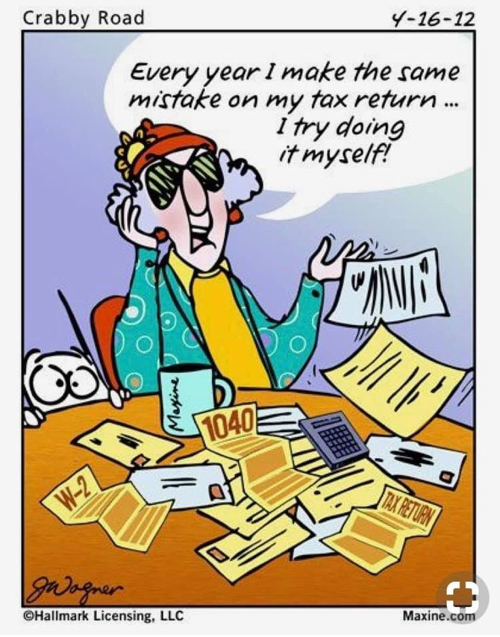

CENTRELINK

Claiming FTB
To claim family tax benefit, you need to apply to the Family Assistance Office by either lodging online via MyGov or completing a paper claim form. You can register and receive regular fortnightly payments or opt to receive a lump sum amount when your tax return is lodged. If you have not registered, then you will need to lodge a lump sum claim form when your tax return is lodged. Note: the claim period for these payments is 12 months meaning the 2024/25 claim must be completed by 30th June 2026.

Seniors Health Care Card / Eligibility for Pharmaceutical Benefits
The card is available to those who have reached age pension age, but do not qualify for the age pension, and whose adjusted taxable income is below $99,025 for a single and $158,440 for a couple. This gives only limited benefits - BUT it may give eligibility for Commonwealth Pharmaceutical Benefits. Please note that it is an adjusted income test and includes a deemed amount from superannuation pension accounts.

Pensioner Deeming Rates
Centrelink deems a specified interest rate (currently for single persons 0.25% on first $64,200 (couples $106,200), 2.25% thereafter on all financial assets, regardless of what they actually earn. The government has committed to freezing these rates until the 30th June, 2026.

Pension Asset and Income Tests
The aged pension starts to reduce for home-owners from $314,000 of assets for singles and from $470,000 for couples. The aged pension cuts out all together at $697,000 for singles and $1,047,500 for couples. These limits are increased by $252,000 for non-homeowners. As the pension changes $3 per fortnight for every $1,000 asset change, it is more important than ever to keep your Centrelink details up to date. For anyone above the cut-off it is sensible to review your figures regularly.
The income test starts to reduce the pension after income exceeds $212 p/f for singles and $372p/f for couples by 50 cents per excess dollar. The work bonus excludes the first $300 per fortnight of your income from this income test which includes work from wages and business.
Note both the assets and the income test apply and test that given the lower pension result is the one applied.

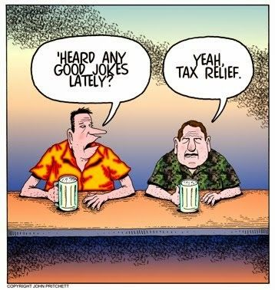

OTHER

Drought Assistance
South Gippsland and Wellington Shire have been added to Business Victoria’s list of those areas eligible for on-farm drought infrastructure grants of up to $5,000, for a variety of drought mitigation measures (dam cleaning, water & track repairs, feed storage sheds, wind breaks etc) incurred after the 30/9/2024.
Rural finance, who co-ordinate the applications, advise that the state government hasn’t updated the grant guidelines that would allow applications, but expect this to happen shortly.

Deducting Fees from Refunds
Due to increased regulations and costs our trust account is no longer in use. This means where our fee was previously deducted from your refund, now payment for the completion of your income tax return will need to be made on the day of your appointment (or before lodgment of your Income Tax Return).

Tax Scams
The tax and MyGov areas have become a prime target for cyber criminals.

For all incoming communication from the ATO

- If you receive an email, SMS or phone call that says its from the ATO, STOP and take a breath.
- If it includes a link - IT IS A SCAM. Do not engage and report it.
- If it includes an attachment (usually in email) IT IS A SCAM. Do not engage and report it.

Remember

- The real ATO will never send you any links to click on.
- If the real ATO does contact you, they will only ever ask you to contact them directly via their official sites such as http://www.ato.gov.au or http://my.gov.au/.
- Call the ATO on 1800 008 540 if you are unsure or want to clarify something.

